INSTRUCTIONS FOR COMPLETING THE
SELF-REPRESENTED LITIGANT REQUEST FOR VISITATION PACKET

PLAINTIFF

The Plaintiff is the parent who wants visitation and files the case with the Court. The Defendant is the other parent or person with custody of the child or children, also called the custodial party. The instructions in this packet are for the Plaintiff.

WARNING: You are strongly encouraged to seek the advice of an attorney before filing any legal matter. This packet is designed to provide information and forms to people who are representing themselves in court. If you proceed without an attorney, it may negatively affect your legal rights. If you are unsure whether to proceed, or have questions about these forms or your legal rights, please consult an attorney. Please note that clerks of court, court staff, and judges may give you information about the court and its procedures but cannot give you legal advice.

DISCLAIMER: The information in this packet is not legal advice and cannot replace the advice of competent legal counsel licensed in your state. Visitation laws vary from state to state and the information contained in this packet is specific to South Carolina. Please note that the information contained in this packet is subject to change. Before filing, make sure that you have the most current version at www.sccourts.org.

The information in this packet is intended for use by parents seeking visitation and is not intended for use by grandparents or other relatives seeking visitation. It is recommended that a grandparent or other relative seek advice from an attorney to seek visitation.

The following instructions will help you file for visitation in South Carolina without an attorney. This is called pro se or self-represented litigant (SRL). While the self-represented litigant may not incur the attorney expense, someone acting without an attorney does not have the expert guidance that an attorney can provide. The other party may choose to hire an attorney. If your visitation request is denied, you could be required to pay the other party's attorney's fees and costs.

If you do not know an attorney who can assist you, you may call the South Carolina Bar's Lawyer Referral Service at 1-800-868-2284 and ask for a Family Law attorney in your county. Members of the South Carolina Bar's Lawyer Referral Service have been in practice for more than 3 years, are in good standing, have provided proof of malpractice insurance, and have agreed to provide a 30 minute consultation for no more than $50. If you cannot afford an attorney, you may contact South Carolina Legal Services (SCLS) through the Legal Aid Telephone Intake Service at 1-888-346-5592. Please note that to qualify for a legal aid attorney through SCLS, your income must not be more than 125% of the Federal Poverty Guidelines.

PART 1: BEFORE YOU FILE

You are strongly encouraged to speak with an attorney if your name is on a child abuse registry, sex offender registry, or if there is currently a restraining order or bench warrant out against you.

Does your child(ren) currently live in South Carolina?

The information in this packet only applies to those seeking visitation with child(ren) who live in South Carolina. Generally, the child(ren) must have lived in South Carolina for the past six months. If your child(ren) is in South Carolina, you must file for visitation in the county where the child(ren) lives.

Is there already a court order for visitation?

The forms in this packet are for someone who is asking the court to establish visitation. They are not the right forms if you already have a court order and want to change the visitation schedule.

If you already have a court order and the custodial party is not following the visitation schedule or not allowing you to visit the child(ren), you may want to contact an attorney or the Clerk of Court in the county where your order is for more information.

If you are the father and have questions about paternity, see the Frequently Asked Questions for Paternity on the Self-Help Resources page.

Filing these papers and having a hearing does not mean you will get visitation. The Judge will decide. The custodial party may ask for child support even if the Judge denies your request for visitation.

PART 2: COMPLETING YOUR PAPERWORK
The following forms are included in this packet:

Step 1 – FILING
- Family Court Coversheet (SCCA 467)
- Summons (SCCA 401F)
- Complaint – Visitation (SCCA 400.41 SRL-VIS)
- Motion and Affidavit to Proceed In Forma Pauperis (SCCA 405)
- Order In Forma Pauperis (SCCA 405.1)
- Financial Declaration (SCCA 430)

Step 2 – SERVICE
- Service of Process Forms
  - Acceptance of Service (SCCA 400.42 SRL-VIS)
  - Affidavit of Service by Mailing (SCCA 400.43 SRL-VIS)
  - Affidavit of Service (SCCA 402F)

Step 3 – REQUEST FOR HEARING
- Request for Hearing (Visitation) (SCCA 400.44 SRL-VIS)
- Affidavit of Service by Mailing (Notice of Hearing) (SCCA 400.45 SRL-VIS)

Step 4 – HEARING
9. Script for Plaintiff's Testimony Hearing (Visitation) (SCCA 400.46 SRL-VIS)
10. Order – Visitation (SCCA 400.47 SRL-VIS)

Some of the information on each form will be the same, such as your name and address, but each form has a different purpose and requires different information. Some of your documents will have to be notarized. This means that a notary must watch you sign the documents and provide the notary's seal. You will need to bring picture identification. You can find a notary at a bank, funeral home, post office, or courthouse. The notary may charge no more than $5 per form (cash only). Below is an image of a notary block. If you see this on a form, it must be notarized.



It is important that you make copies of all paperwork. Keep the copies of the paperwork in a safe place and bring your copy to court with you. If any necessary information is missing, you risk your case being dismissed or delayed. If your case is dismissed, you may have to begin again by filing your information with the Clerk of Court a second time and paying the filing fee of $150.00 again.

STEP 1 - FILING

You will start with the first five forms:

- Family Court Coversheet (SCCA 467)
- Summons (SCCA 401F)
- Complaint – Visitation (SCCA40.41 SRL-VIS)
- Motion and Affidavit to Proceed In Forma Pauperis (SCCA 405) (if applicable)
- Financial Declaration (SCCA 430)

Fill in the name of the county where you are filing the case in the upper left hand corner of each of these documents. This is the county where your child(ren) lives. Then print your name in the space labeled Plaintiff. Next, print the name of the child(ren)'s other parent or the custodial party in the blank above the word Defendant. This section of all legal forms is called the caption. This caption should be completed on all forms filed with the court.

SEE THE CHART STARTING ON PAGES 12-13 TO FIND YOUR JUDICIAL CIRCUIT.
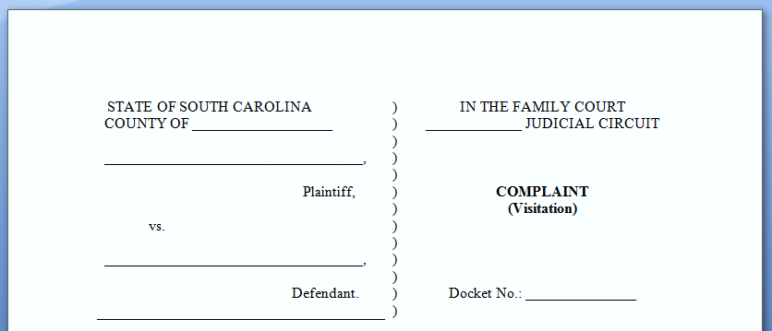

Family Court Coversheet

On the Family Court Coversheet (SCCA 467), print your contact information in the spaces below the caption. Print your full name, address, email address (if you have an email address), and a reliable phone number.

If the county where you are filing is a mandatory mediation county, check the first box under DOCKETING INFORMATION. A list of these counties is at the top of the second page of the Family Court Coversheet. If you are filing in one of these counties, you are required to participate in mediation. There may be a fee for mediation.

A family mediator is a person who helps both parents reach an agreement about visitation. This process often helps the case move more quickly. Also, it teaches the parents how to work out problems. When the parents can work together to solve problems, the child(ren) feel less stress.

Sign and date the Coversheet at the bottom of the page.

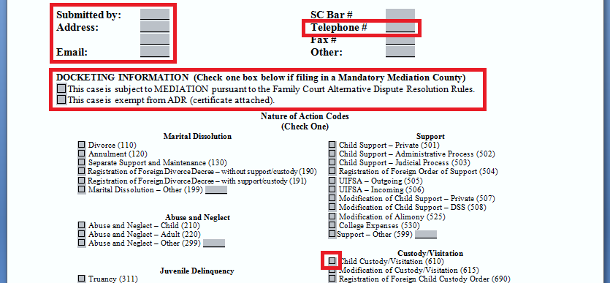
Summons

On the Summons (SCCA 401F), fill in the name of the city where you live, then date and sign. Print your name and your address.

Complaint

Fill in the blanks and boxes in paragraphs 1 through 5 in the Complaint - Visitation (SCCA 400.41 SRL-VIS).

Paragraph 6 lists basic visitation. If you want something different, write it in paragraph 7.

At the bottom of the Complaint, fill in the name of the city where you live. Date and sign the Complaint.

Motion to Proceed In Forma Pauperis

The filing fee is $150. If you are unable to pay the filing fee, you may file the "Motion and Affidavit to Proceed In Forma Pauperis" (Form SCCA 405) with your signed and notarized Financial Declaration. By filling out and signing this form and having it notarized, you are swearing under oath that you do not have the funds available to pay the filing fee ($150). Do not sign this form until you are in front of a notary public. The notary must watch you sign the form.

The Judge will review your motion and complete the order. If the motion is denied, you must pay the filing fee ($150) and other fees by the date set by the court. If the fee is not paid on or before that date, your case will be dismissed, and you will have to begin the process again by re-filing your information. If the Judge grants your motion, you may proceed without paying the filing fee.

Financial Declaration

The Financial Declaration (SCCA 430) asks questions about the finances of both parties. Only fill out the sections of the form that apply to you. Attach a copy of your most recent pay stub or benefits statement. Fill in your gross monthly income. This is the amount of money you earn before taxes, social security, or any deductions are taken out. When figuring your monthly income and expenses, multiply any weekly amounts by 4.33 to get the monthly amount. Do not sign this form until you are in front of a notary public. The notary must watch you sign the form.

Completing the Filing Process

The next step is to file the papers with the appropriate Clerk of Court, Family Court Division, and to pay the filing fee ($150), if applicable. You will file this in the county where your child(ren) lives. Physical locations of all South Carolina Family Courts can be found on pages 12-13 of these instructions, in the telephone book, or online at www.sccourts.org.

Make two copies of the entire packet. Take the copies and the originals to the Clerk of Court in the county where your child(ren) lives. If you are paying the fee, the Clerk of Court will: (1) assign your case a docket number; (2) record the docket number on the upper right hand corner of all of the forms; (3) keep the originals; and (4) return two copies of the forms to you. The Clerk will keep the original and return two clocked copies to you. One copy is for you to keep. The other copy is to serve on the Defendant.

It is important that you print the docket number that has been issued for your case on all future forms you file with the court.

The filing fee is $150. You cannot pay with a personal check, credit or debit card; you can pay with cash, a bank check, or a money order.

If you cannot afford the filing fee, then you can file the Motion and Affidavit to Proceed In Forma Pauperis. You will not have to pay to file, but you may have to pay the fee after the Judge reviews your information and signs the Order. You should take a large brown envelope with enough postage to mail everything back to you. The envelope should be addressed to you. You will receive the envelope in the mail in about two weeks. Look at the Motion and Affidavit to Proceed In Forma Pauperis. If the box at the bottom marked "granted" is checked, your documents should have a date stamp and a docket number on them. Now you can serve the papers on the Defendant.

If the motion is denied, you must pay the filing fee ($150) and other fees by the date set by the court. If the fee is not paid on or before that date, your case will be dismissed, and you will have to begin the process again by re-filing your information.

STEP 2: SERVICE OF PROCESS

READ THIS SECTION CAREFULLY. If you do not serve these papers correctly, you may not be able to proceed.

There are two steps for service of process.
- Serve the Defendant with one clocked copy of the Family Court Coversheet, Summons, Complaint (Visitation), and the Financial Declaration.
- Prove to the court the Defendant was properly served.

You must serve the Defendant in one of five ways. If one way is not successful, try another one. The most effective way to serve the Defendant is through the Sheriff's Office or by private process server. There will be a fee for this service.

1) SHERIFF'S OFFICE

Contact the Sheriff's office in the county where the Defendant lives or works to serve the papers. There will be a fee for this service. When the Sheriff serves the papers you filed with the court, ask the office to complete the bottom half of the Affidavit of Service (SCCA 402F) form before a notary, have the form notarized, and return the form to you. Many Sheriff's Offices use their own Affidavit of Service Form. File the Affidavit of Service with the Clerk of Court. Keep a copy for your own file.

2) PRIVATE PROCESS SERVER

Private process servers are listed in the telephone book and online. There will be a fee for this service. It is usually more expensive than the Sheriff's Office. Give the process server the Affidavit of Service (SCCA 402F) from this packet, along with the papers you filed with the court. The process server will give you the completed Affidavit of Service Form or their own form after they have served the papers. File the Affidavit of Service with the Clerk of Court. Keep a copy for your own file.

3) SERVICE BY COMMERCIAL DELIVERY SERVICE
You may use a commercial delivery company like UPS or FedEx to serve the papers you filed with the court. The company must be one approved by the Internal Revenue Service. You may check to be sure the company is approved at the IRS website: https://www.irs.gov/uac/Private-Delivery-Services-PDS
You need the delivery record. The delivery record will show the date, time and place of delivery, the name of the person served and will have an original signature or electronic image of the signature of the person served. If someone other than the Defendant signs for the documents, you will not be able to proceed if the Defendant does not appear. If delivery is refused or returned undelivered, you must try another method. You can get a copy of the delivery record at the delivery company's office, by calling the delivery company, or going online and printing a copy. You will need the tracking number that is printed on your receipt.
Complete an Affidavit of Service By Mailing (SCCA 400.43 SRL-VIS) showing the documents served with the delivery record attached. Do not sign the Affidavit of Service By Mailing form until you are in front of a notary public. The notary must watch you sign the form. This affidavit and delivery record must be filed with the Clerk of Court. Keep a copy for your own file.
4) U.S. MAIL

You may use U.S. Mail. If you do, you must send these documents Certified Mail, Restricted Delivery, Return Receipt Requested.

When you get the return receipt card (green card) back from the U.S. Post Office, check it to make sure the Defendant signed the card. If anyone other than the Defendant signed the return receipt card (green card), you do not have good service and must try again.

If you receive the return receipt card (green card) and it was signed by the Defendant, record the docket number you received from the Clerk of Court and the words "Summons and Complaint" across the top of the return receipt (green card) and then make a copy of the card for your file.

Next, complete and sign the Affidavit of Service by Mailing form (SCCA 400.43 SRL-VIS) before a notary. Do not sign this form until you are in front of a notary. The notary must watch you sign the Affidavit of Service by Mailing. Attach the return receipt card (green card) to the notarized Affidavit of Service by Mailing and take it to the Clerk of Court's office for filing.

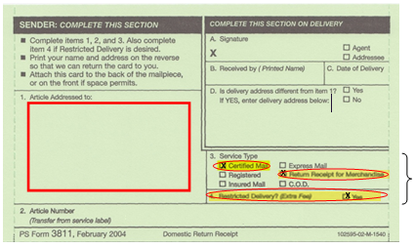
FRONT

Defendant's Name
and Address
Check, highlight and circle these fields

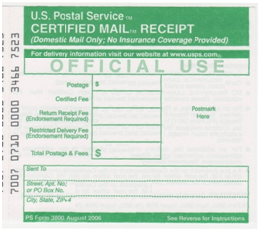

Check with your local Post Office for the fees

Defendant's Name and Address

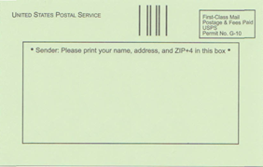

BACK

Your Name and Address

Keep a copy for your own file.

5) ACCEPTANCE OF SERVICE

If the Defendant is willing to accept service, have the Defendant complete the Acceptance of Service Form (SCCA 400.42 SRL-VIS). Handing the papers to the Defendant yourself is not good service of process unless the Defendant is willing and completes the acceptance form. Take the completed form to the Clerk of Court's office for filing. File the Acceptance of Service with the Clerk of Court and keep a copy for your files.

If the Defendant is not served properly, you will not be able to proceed.

STEP 3 – REQUEST FOR HEARING

Complete the Request for Hearing (Visitation) (SCCA 400.44 SRL-VIS). Print your name in the space marked "Plaintiff." Print your address, telephone number, and email address where requested. Complete the information for the Defendant or the Attorney for Defendant. Print any comments or issues that you would like to bring to the Court's attention and sign your name at the bottom of the form where it says "Plaintiff."

Take the original and a copy of the Request for Hearing to file with the Clerk of Court. The Clerk will clock your copy as filed and give it back to you for your records. The Clerk of Court will inform you of your hearing date. The hearing date may be several weeks or months away.

After you receive the Notice of Hearing from the Court,

- Immediately send a copy of the Notice of Hearing to the Defendant or Defendant's attorney.

- The Notice of Hearing must be sent by certified mail, return receipt requested.

- Complete the Affidavit of Service by Mailing (Notice of Hearing) (SCCA 400.43 SRL-VIS) and sign before a notary. The notary must watch you sign. Attach a copy of the returned mail receipt and the green card if you receive it from the post office.

- File the Affidavit of Service by Mailing (Notice of Hearing) (SCCA 400.43 SRL-VIS) prior to the hearing. Keep a copy for your own file.

If the envelope used to mail the Notice of Hearing to the Defendant or Defendant's attorney is returned from the U.S. Post Office, take the returned envelope to the hearing. It is only necessary to show that the Notice of Hearing was mailed to the Defendant's last known address (or their attorney's address). You do not have to show that the Defendant or Defendant's attorney actually received the notice.

STEP 4 – HEARING

This packet has a Script for Plaintiff's Testimony (SCCA 400.46 SRL- VIS) that you should use at the hearing. Review and complete the script before your hearing.

Complete the Order (Visitation) (SCCA 400.47 SRL-VIS). On the Order, print the date assigned for your hearing and list the first name and initial of the last name and the year of birth for each child.

On the day of your hearing:

- Arrive at the courthouse at least thirty (30) minutes prior to your scheduled time.
- Bring copies of your court documents.
  - If you have any other documents that you want the Judge to see, bring the original and two copies to court.
- Dress appropriately.
  - Appropriate dress includes suits, jackets, dresses, dress slacks, and neatly tucked shirts.
  - Do NOT wear casual clothing such as sweat clothes, tank tops, shorts, and similar summer beachwear.
  - Remove hats when entering the courthouse, unless they are required for a medical condition.
- Make arrangements for a responsible adult to watch your child(ren) while you are in court.
- Turn off your cell phone.

When it is time for your hearing, the Courtroom Deputy will call your name. At that time, enter the courtroom and wait for instructions. Before you begin, you will be sworn in. When the Judge is ready, the Judge will tell you to begin or to present your case. You will read the script as your testimony. Some Judges will ask you questions instead.

You are required to make your case for visitation.

Make sure you tell the Judge everything that shows that you should be given visitation with your child(ren). Bring a copy of your work schedule with you to court. This should be on your company letterhead or printed from your company's website. This will be used to show the Judge when you are not working and can visit with the child(ren). This is especially important if you work a swing shift or work weekends. If you have any papers that you want the Judge to see, hand the original and a copy to the Courtroom Deputy who will give the original to the Judge and a copy to the Defendant. Be sure to keep another copy for yourself in case the Judge or the Defendant asks you questions about it.

The Judge may stop you from time to time to ask a question. Listen carefully and answer the questions the Judge asks you. The Defendant or the Defendant's attorney has the right to ask you questions, called cross-examination. When you are finished testifying, the Judge will indicate that you may leave the witness stand or sit down at the table. The Defendant will have a chance to testify as well, and you will have a chance to ask the Defendant questions. At the end of the hearing, the Judge may tell you the decision or state that a decision will come later.

If the judge grants your request at the hearing, the Judge will likely sign the Order (Visitation). You may ask the Deputy to hand the Judge the order to finish completing. Make sure the Order (Visitation) is filed with the Clerk of Court.

The Clerk of Court will provide you and the Defendant or the Defendant's attorney with a clocked copy of the Order (Visitation). If the Judge does not sign the Order at the hearing, the Judge will give the signed Order to the Clerk, and the Clerk will mail a copy to you and to the Defendant.

The Order must be signed by the Judge and filed with the Clerk of Court before you have the scheduled visitation.

Family Court Clerk of Court Addresses

County | Judicial Circuit | Physical Address | Phone Number
Abbeville | 8th | 102 Court Sq., Abbeville, SC 29620 | 864-366-5312
Aiken | 2nd | 109 Park Ave., SE, Aiken, SC 29801 | 803-642-1715
Allendale | 14th | 292 Barnwell Hwy. Allendale, SC 29810 | 803-584-2737
Anderson | 10th | 100 S. Main St., Anderson, SC 29624 | 864-260-4053
Bamberg | 2nd | 2959 Main Hwy., Bamberg, SC 29003 | 803-245-3025
Barnwell | 2nd | 141 Main St., Barnwell, SC 29812 | 803-541-1020
Beaufort | 14th | 102 Ribaut Rd., Beaufort, SC 29902 | 843-255-5050
Berkeley | 9th | 300 California Ave., Moncks Corner, SC 29461 | 843-719-4406
Calhoun | 1st | 902 South F. R Duff Dr., St. Matthews, SC 29135 | 803-874-3524
Charleston | 9th | 100 Broad St., #106, Charleston, SC 29401 | 843-958-5000
Cherokee | 7th | 125 E. Floyd Baker Blvd., Gaffney, SC 29340 | 864-487-2571
Chester | 6th | 140 Main St., Chester, SC 29706 | 803-385-2605
Chesterfield | 4th | 200 W. Main St., Chesterfield, SC 29709 | 843-623-2574
Clarendon | 3rd | 3 W. Keitt St., Manning, SC 29102 | 803-435-5120
Colleton | 14th | 101 Hampton St., Walterboro, SC 29488 | 843-549-5791
Darlington | 4th | One Public Square, Darlington, SC 29532 | 843-398-4330
Dillon | 4th | 301 W. Main St., Dillon, SC 29536 | 843-774-1425
Dorchester | 1st | 5200 E. Jim Bilton Blvd., St. George, SC 29477 | 843-563-0120
Edgefield | 11th | 129 Courthouse Square, Edgefield, SC 29824 | 803-637-4080
Fairfield | 6th | 101 S. Congress St., Winnsboro, SC 29180 | 803-712-6526
Florence | 12th | 180 N. Irby St., MSC-E, Florence, SC 29501 | 843-665-3031
Georgetown | 15th | 401 Cleland St., Georgetown, SC 29442 | 843-545-3036
Greenville | 13th | 305 E. North St., Ste. 232, Greenville, SC 29601 | 864-467-8551
Greenwood | 8th | 528 Monument Street, Greenwood, SC 29646 | 864-942-8546
Hampton | 14th | 1 Elm St., Courthouse Square, Hampton, SC 29924 | 803-914-2250
Horry | 15th | 1301 Second Ave., Conway, SC 29526 | 843-915-5080
Jasper | 14th | 265 Russell St., Ridgeland, SC 29936 | 843-726-7710
Kershaw | 5th | 1121 Broad St., Camden, SC 29020 | 803-425-7223
Lancaster | 6th | 104 N. Main St., Lancaster, SC 29720 | 803-285-1581
Laurens | 8th | 100 Hillcrest Square, Laurens, SC 29360 | 864-984-3538
Lee | 3rd | 123 S. Main St., Bishopville, SC 29010 | 803-484-5341
Lexington | 11th | 205 E. Main St., Lexington, SC 29072 | 803-785-8212
Marion | 12th | 103 N. Main St., Marion, SC 29571 | 843-423-8240
Marlboro | 4th | 105 Main St., Bennettsville, SC 29512 | 843-479-5613
McCormick | 11th | 133 S. Mine St., McCormick, SC 29835 | 864-852-2195
Newberry | 8th | 1226 College St., Newberry SC 29108 | 803-321-2110
Oconee | 10th | 205 W. Main St., Walhalla, SC 29691 | 864-638-4280
Orangeburg | 1st | 151 Docket St., Orangeburg, SC 29115 | 803-533-6243
Pickens | 13th | 214 E. Main St., Pickens, SC 29671 | 864-898-5867
Richland | 5th | 1701 Main St., Columbia, SC 29201 | 803-576-1929
Saluda | 11th | 100 E. Church St., Saluda, SC 29138 | 864-445-4500
Spartanburg | 7th | 180 Magnolia St., Spartanburg, SC 29306 | 864-596-2591
Sumter | 3rd | 141 N. Main St., Sumter, SC 29150 | 803-436-2237
Union | 16th | 210 W. Main St., Union, SC 29379 | 864-429-1630
Williamsburg | 3rd | 125 W. Main St., Kingstree, SC 29556 | 843-355-9321
York | 16th | 1070 Heckle Blvd., Rock Hill, SC 29732 | 803-909-7100

Plaintiff Visitation Checklist

- Complete the forms in Section 1 of this packet -- Family Court Coversheet, Summons, Complaint, Motion and Affidavit to Proceed In Forma Pauperis (if needed), and Financial Declaration Form.

- Make two copies of these forms.

- File these forms with the Clerk of Court in the appropriate county and pay the $150 filing fee unless the motion to proceed In Forma Pauperis has been granted.

- Serve copies of these forms on the Defendant in one of five ways: (1) Sheriff's office, (2) Private Process Server, (3) Commercial Delivery Service, (4) U.S. Mail, (5) Acceptance of Service.

- Complete the Request for Hearing and file it with the Proof of Service with the Clerk of Court.

- Once you receive the Notice of Hearing from the Clerk of Court, mail a copy of this Notice to the Defendant or the Defendant's attorney by certified mail. File the Affidavit of Mailing with the Clerk of Court.

- To prepare for your hearing, complete the Script and the Order (Visitation).

- On the day of your hearing, you should arrive at least 30 minutes early, dress appropriately, turn off your cell phone, and remove your hat. Do not bring your children.

- At the hearing, you will testify using the Script for Plaintiff's Testimony. The Defendant or the Defendant's attorney and the Judge may ask you questions.

- The Judge will also allow the Defendant to present his/her case, and you will have an opportunity to ask questions.

- At the end of the hearing, the Judge may grant or deny your request or tell you a decision will come later. The Judge may sign the Order (Visitation) or make his or her own Order.

- If the judge signs your Order (Visitation), be sure that the signed Order is filed with the Clerk of Court's office and you receive a clocked copy for your files.

- If the Judge does not sign the Order at the hearing, a copy will be mailed to you.

