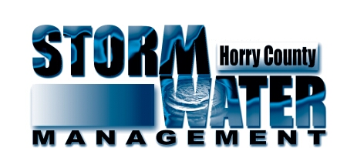

Policy Number: SW- Beaver Effective Date: 1/01/22
Subject: Beaver Bounty Program Revision: 1/01/22

- Purpose
  - The purpose of this document is to provide Standard Operating Procedures (SOP) for the collection of beaver bounties by the public. The Beaver Bounty program is to provide a secondary measure to help reduce the number of beaver dams in Horry County. This program is not an effort to eradicate all beavers. This program also will pay for beavers that are not causing a nuisance to public infrastructure. Bounties shall only be paid for beavers collected within Horry County.

- Responsibilities
  - The Horry County Stormwater Manager is responsible for administration of this policy.
  - A Horry County Stormwater employee will be responsible for the collection and documentation of this program.
  - The Horry County Stormwater Office Manager will be responsible for processing the bounty payments.

- Collection
  - Horry County will set up a station at the Public Works Complex on Fridays from 8 am to 12 pm. This will be the only day that the bounties will be accepted.
  - The County will only accept the front paws of the beaver. The paws shall be frozen and kept in a zip lock plastic bag.
  - A Beaver Bounty Receipt and Application form shall be completed by the citizen applying for the bounty. This application must be filled out in its entirety and signed by the landowner where the beaver was collected. It must be verified that the beaver was collected within Horry County.
  - The citizen requesting the Bounty shall show proof of one of the following: a valid SCDNR Hunting License and a valid SCDNR Commercial Furbearing Trapper License, or a valid SCDNR Depredation permit if the beaver was collected on their personal property. The license or permit number must be recorded on the application, and a copy of the Driver’s license and Permits shall be collected.
  - A W-9 and ACH payment form must be filled out by the citizen in order to receive payment. The forms will be submitted to finance. After processing the information the County will mail the applicant their payment.
  - The information from the Receipt and Application form shall be entered into an access database. If the applicant has previously submitted a W-9 within 12 months than a new form will not be required if the information is still valid.

- Dam Removal
  - A service request will be created after the applicant has collected the Bounty. The Service Request will be submitted to the appropriate Stormwater Project Manager to follow up and verify if there are any dams remaining and determine if the dam needs to be removed. If it is determined that the dam needs to be removed the Project Manager will create a work order and try to obtain the easements to allow the County to remove the dam. Dams shall only be removed by the County if they are effecting public infrastructure.

- General Disclaimer
5.1 All participants in Horry County Stormwater Management’s Beaver Bounty Program (the “Program”) do so voluntarily at their own risk and peril. Nothing contained in any Program materials shall be construed as to grant a participant any rights of entry or access to another’s real property without first obtaining permission nor does the Program alleviate participants from adhering to all local, state, and federal laws, including but not limited to, those imposed by SCDNR with regard to the hunting and/or trapping of beavers.

